The Lifeline for Cleeve Prior was the London Midland & Scottish [LMS] Railway which linked Evesham up to Birmingham through Salford Priors & Broom Junction, and then over to Stratford Old Town station through to London.

Salford Priors Station was the nearest official stop on the railway, & it was from here that people from the village would have to leave the train to walk the mile or so across the water meadows, across the narrow bridge over the weir, up the village steps & in to the village.

Below is an undated view looking along the Salford Priors platform towards Evesham, with the goods shed partly visible on the right. The bridge carried the road from Bidford to Salford Priors.

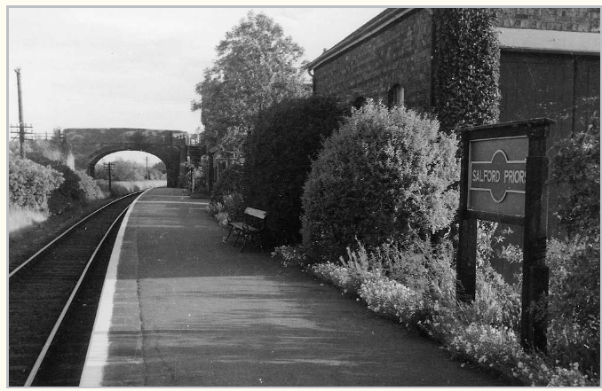

Courtesy of <http://www.warwickshirerailways.com/index.htm>

The line to Evesham followed the line of the new by pass, behind Greenhill & then it swung in to the site of the GWR station in Evesham. It crossed the Oxford line, keeping to its own tracks & ran into the second Evesham station, now called Signal House opposite the current station buildings.

We see below the two stations on the plan below. Note on the drawing how the Railway Public House is isolated between the two lines alongside the road between the two bridges.

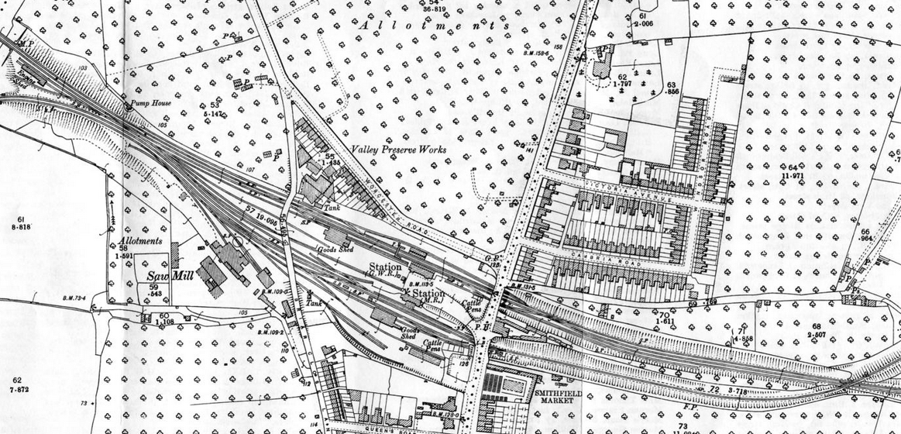

The picture below which is the mirror image of the current station is the old LMS Station. The road bridge in the distance is today where the car wash is located today & the new flats next to the railway pub were built over the cutting beyond .

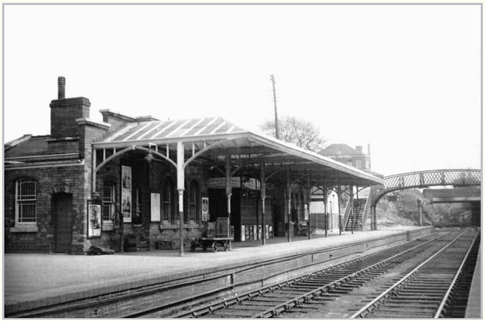

Courtesy of http://www.warwickshirerailways.com/index.htm

The view is looking towards Redditch with the single platform station facilities on the left and the goods yard also to the left beyond the station. The layout of the station was very similar to Harvington, the next station down the line. The station master's house and the passenger and booking office facilities are identical in layout whilst the goods yard is similarly configured with a passing loop although Salford Priors had an additional siding used by coal merchants.

Travelling up the line through Salford Priors to Birmingham you came to Broom Junction, a large intersection with the southern signal box being seen derelict adjacent the new bypass to Alcester. It was at this Junction that the trains left the Birmingham line to go to Stratford & up to London.

|  |  |
| --- | --- |
| |  | | --- | | Close up of  passengers waiting on Broom Junction's platform for a SMJ train to arrive to take them forward to Stratford upon Avon |   Close up of image showing passengers waiting on Broom Junction's platform for a train to arrive to take them forward to Stratford upon Avon. The ladies were evidently being well looked after because alongside the group in the foreground and the lady to the left are porters trolleys and barrows to aid the transfer of their luggage. The sign on the bracket signal warned passengers not to cross the line via the foot boards seen crossing the line in front of the locomotive.  Courtesy of [http://www.warwickshirerailways.com/index.htm mrbj154](http://www.warwickshirerailways.com/index.htm%20mrbj154)  The journey to Strafford did not pass through the Stratford station you see today, as this sat on the Great Western Railway [GWR] line which went down what is now the Greenway to Cheltenham. The LMS line to London passed through Stratford Old town Station which was located adjacent the river, where the western bypass today crosses the Avon over the road bridge, this was originally the position of a railway bridge. |

We see below the view of Stratford Old Town Station looking back to the Junction with the GWR Stratford-Honeybourne-Cheltenham line

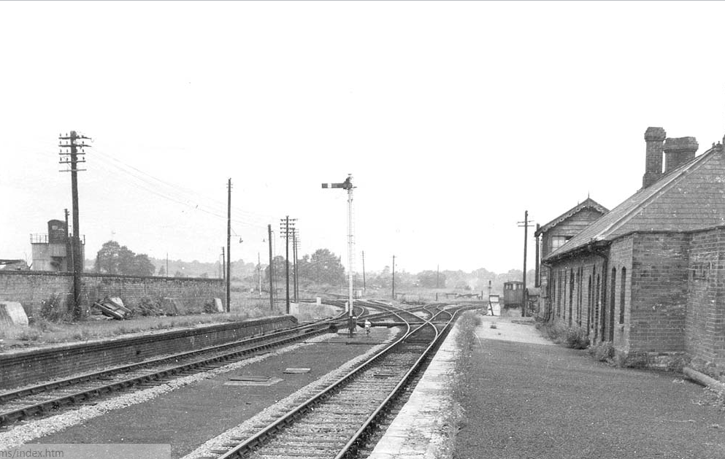

Courtesy of <http://www.warwickshirerailways.com/index.htm> & [Lens of Sutton](http://www.warwickshirerailways.com/lms/smjsa64.htm)

|  |  |
| --- | --- |
| |  | | --- | |  |   Looking west towards the junction with the ex-GWR Stratford upon Avon to Honeybourne line.  The view today    The same view today. The original platform can still be seen on the theatre side of the road in the undergrowth |
| The railway was the centre of village life in Cleeve Prior. For those whose education was outside the village such as Don Archer, the daily Journey to school at Greenhill School and then the Grammar School in Evesham, was from Salford Priors. This was apart from during the General Strike, when the trains all stopped and Don had to cycle to school. Brodie Halford also travelled from Salford but over to Stratford, but he had the luxury of being taken by pony & trap to the station, rather having to walk over the weir & across the fields. Harold Reeves, would walk over the footbridge to catch the train to Birmingham, and would stay there in digs for a week. Others worked in London such as Wallis Halford from Mill house who before WW1 would send a telegram from Paddington as he waited for his train to depart which would be delivered by a telgram boy on a bycycle to his mother at home , who would then send the publican to send his pony & trap to the station to meet the train.  The railway was a lifeline to support the war effort in both world wars. The Halford” Family Diaries” tell us how on Christmas day 1914, the Grand Parents took a train from the junction to New Street, Birmingham, to wait for a trainload of the “wounded” from the front who were passing through, so they could give them a few “comfort”, they then returned to have Christmas Dinner. In the second world war Cleeve Prior paid host to many soldiers after Dunkirk, which included a unit of six RAF meteorologists & their driver . They describe how they were lifted off the mole at Dunkirk & from Margate were transported to “The Halt” at Cleeve Prior.  They describe their journey’s end as “a wooden platform about 100yds long with a building of wood, presumably the booking office, in the middle. In the usual railway lettering was the village name Cleeve prior on top of the wooden building”. From there lorries collected them & brought them to Cleeve Prior.    The use of Lorries was to start the downfall of the railways & to break the dependence on this mode of transport. The main occupation & industry in the village was market gardening ,and In order to ensure that fruit & vegetables from the Vale of Evesham arrived at market as fresh as possible, the directors of Coventry City Central Market[3C], approached Mary Collins father (who had a transport business in Pebworth) to see if fresh produce could be delivered by road [rather than rail as previously] i.e. collected from the growers’ allotments in the late evening, to arrive in Coventry in the early hours of the following day, in time for the retailers and stall holders to buy before the market was opened to the public at 5.00am.  Starting in 1936, the swift transportation of their produce was immediately popular with the growers, especially as their money (cash in brown envelopes) was brought back in the lorry on the pick-up on the following day. |

